**Front End Developer Interview Task**

**Documentation**

**Company Name :**

Tech2Edge Technology Solutions LLP

**Project Developer :**

Annu Sharma

**Project Overview**

This project is about creating a dynamic front-end web page that highlights details of a TV series. It incorporates a variety of elements such as navigation links, a responsive header, and an episode carousel, all integrated with modern web technologies like HTML, CSS, JavaScript, Bootstrap, OwlCarousel, and jQuery.

**Main Features**

**Navigation Menu**:

* + Contains links to "Home," "TV Shows," and "Movies."
  + Includes a dropdown for selecting characters, which triggers a modal to display character information.
* **Output:** Characters Name

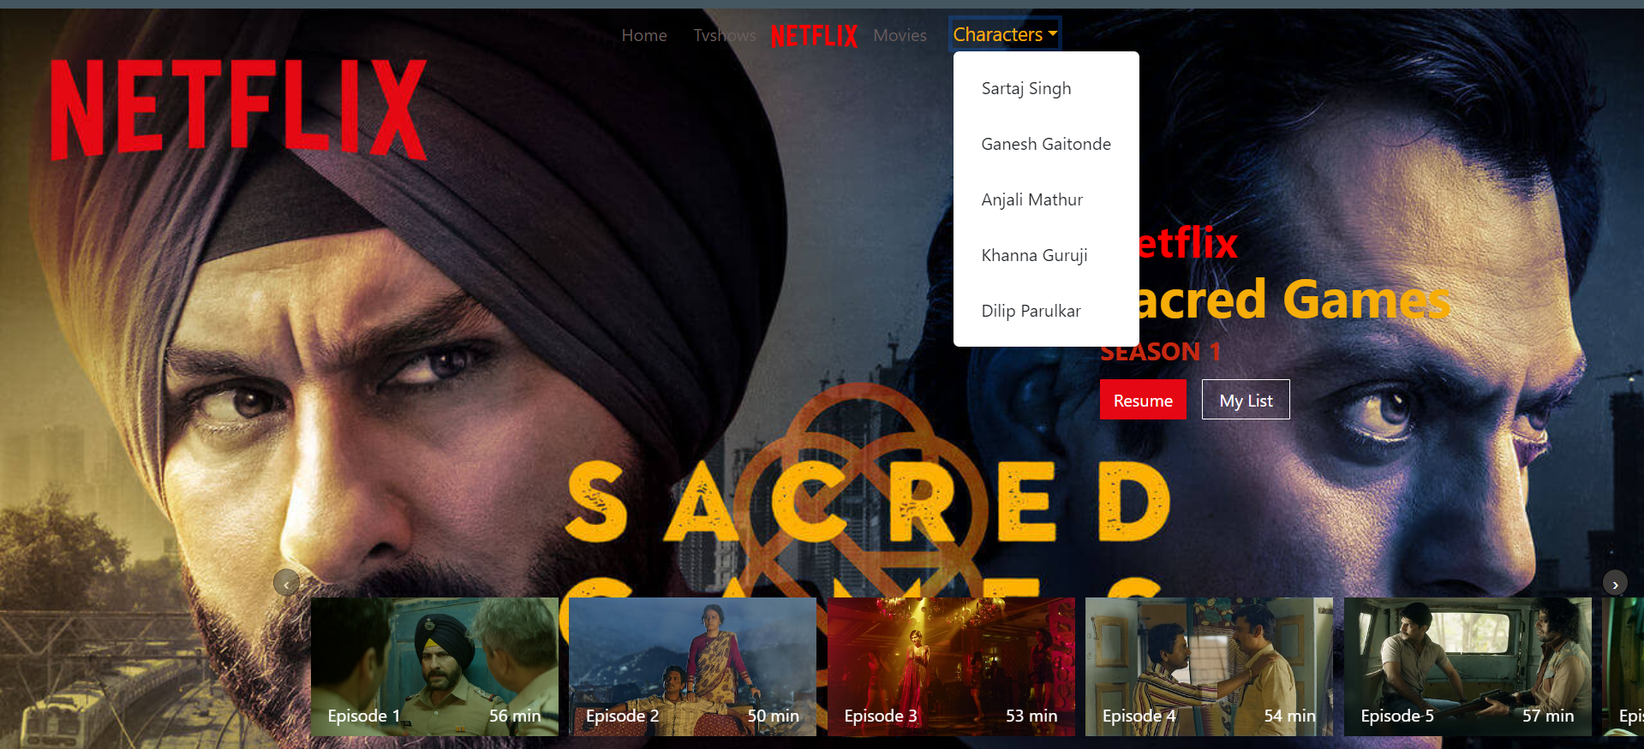

**Hero Section**:

* + Utilizes a full-screen background image that is fetched from an external API.
  + Shows the series title and streaming platform information, both retrieved dynamically.
  + Features "Resume" and "My List" buttons.
* **Output:** Images and Text which is comes from API.

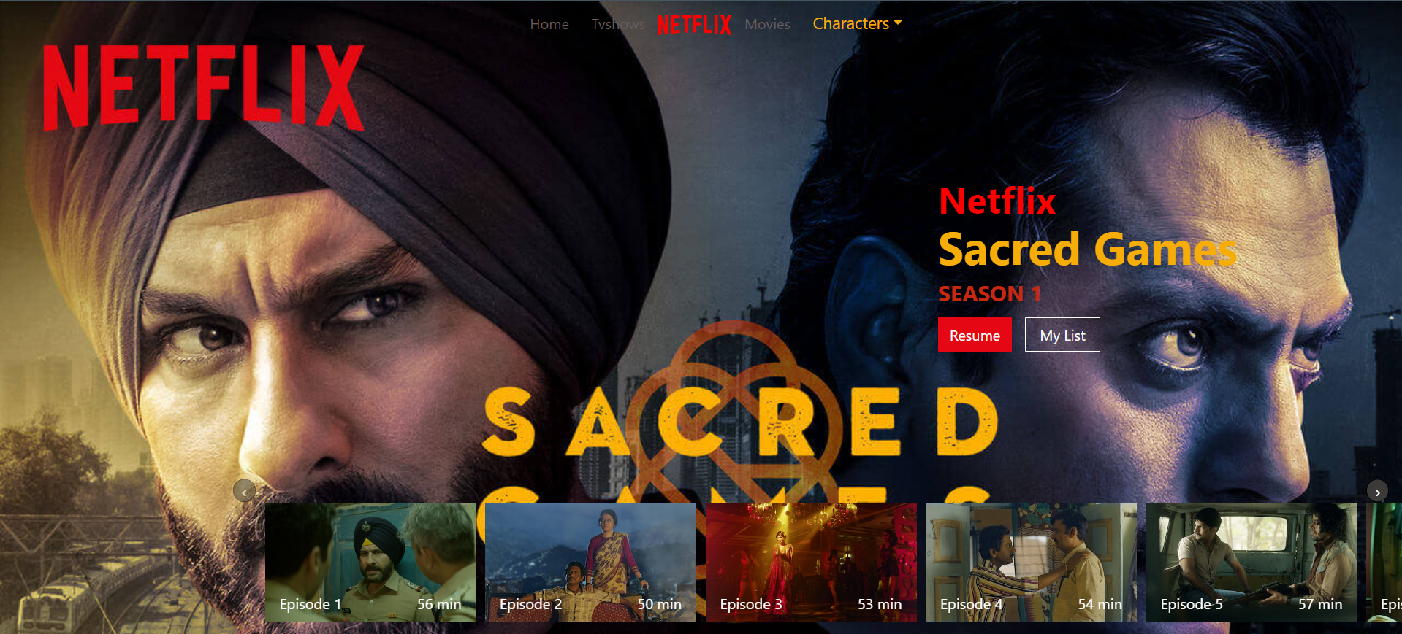

**Episode Carousel**:

* + Implemented using OwlCarousel to create a carousel for browsing episodes.
  + Each episode is represented with an image, title, and duration.
* **Output:**

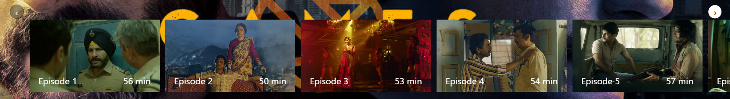

**Character Modal**:

* + Activated by selecting a character from the dropdown menu.
  + Displays a modal with the character’s image and name, updated dynamically.
* **Output:**

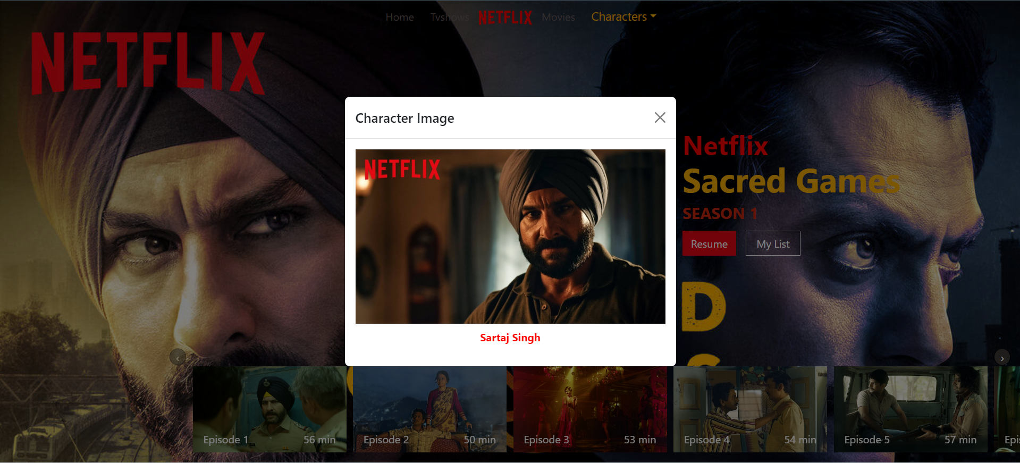

**Functionality**

* **Dynamic Data Loading**:
  + JavaScript fetches and displays data from an external API to update the page’s background, title, and streaming platform.
* **Responsive Design**:
  + The layout adjusts to different screen sizes using Bootstrap and OwlCarousel for a responsive design.

**This Website is not fully Responsive Right now**

* **Interactive Elements**:
  + The dropdown menu triggers a modal window for character details.
  + The carousel allows users to view and navigate through episodes.

**Technologies Employed**

* **HTML**: Provides the foundational structure of the web page.
* **CSS**: Handles styling, including custom design elements and Bootstrap integration.
* **JavaScript**: Manages dynamic content updates and interactions.
* **Bootstrap**: Ensures responsive layout and design.
* **OwlCarousel**: Powers the interactive episode carousel.
* **jQuery**: Simplifies JavaScript operations and event management.

**Objectives**

* Develop an engaging and visually appealing interface for presenting TV series information.
* Incorporate dynamic content updates to reflect the latest data from external sources.
* Achieve a responsive and user-friendly design suitable for various devices.

**References**

**Tools and Websites**

1. VS Code, code editor
2. Web Browsers Firefox, Chrome
3. Bootstrap Documentation
4. **Owl Carousel Documentation**
5. **API Usage**
6. W3 Schools, YouTube, ChatGPT

**My Personal GitHub Link:**

https://github.com/Annu9161

**Links**

1. **Website Image Refernece :** <https://repotech2edge.github.io/tasks/screen/screen.webp>
2. **API :** <https://repo-tech2edge.github.io/tasks/sample.json>